# Project Report

|  |  |
| --- | --- |
| Product Name | Advanced Certificate in Web Development |
| Qualification Name (ITSF) | NICF-Advanced Certificate in Infocomm Technology (Software & Applications) |
| Product Name | NICF-UI Frameworks |
| Module Name (ITSF) | NICF-UI Frameworks |

|  |  |  |  |
| --- | --- | --- | --- |
| Student name | | Assessor name | |
| Joshua Ho Gwok Hin | |  | |
| Date issued | Completion date | | Submitted on |
| 18 Jan 2022 | 14 Feb 2022 | | 14 Feb 2022 |
|  | | | |
| Project title | Design & Develop Front End Community Portal RIA application. | | |

|  |
| --- |
| Learner Declaration |
| I certify that the work submitted for this assignment is my own and research sources are fully acknowledged.  C:\Users\hghjo\AppData\Local\Microsoft\Windows\INetCache\Content.Word\Signature.gif  Student signature: Date: 12 Feb 2022 |

Content

1. Project background
2. Project Objectives
3. Tools and Platform
4. Business Process & Solution Architecture
5. Task 1
6. Task 2
7. Task 3
8. Task 4
9. Task 5
10. Task 6
11. Task 7
12. Task 8
13. Task 9
14. Appendix A: Detail UX Testing Report
15. Appendix B: References
16. Project Background

ABC Jobs Pte Ltd is looking to develop a Community Portal where users will be able to register in the portal using the registration page.   
Users of the portal can also search for other users using various parameters such as First Name, Last Name, Company Name, City & Country.  
Users will be able to view the Public Profile of users after searching them. The portal allow users to login, request for forgotten password and Update their profile information.

1. Project Objective

Objective of this project is to create a working prototype following closely to concepts and principles in User Interface Design.   
Business goals -  
To target users of selected personas, engage target groups to use the platform. The user experience will be based on personas who are software engineers.   
User goals -  
The application interface follows concepts that are User Centered Designing, putting the end user at the center of the universe. Generally with objects easily recognized and identified to perform Tasks. The minimalist design help makes it easy for users.   
Project Deliverables -  
An Axure prototype to be created and presented for presentation, testing and feedback gathering throughout the designing process.

The follow pages/panels to be presented includes:

Functions for scenarios such as log in, register, change password, search other users, and update profile.

Measuring Levels of Success to be conducted to gather for feedback and improvement for the design.

1. Tools & platform

Axure for Wireframing and Prototyping

Basic design concept are first created as wireframes in Axure. Design are then updated with interactions as prototypes for users to perform scenarios on the application.

The main reason for using Axure over other similar wire framing software is the ability to create interactions, providing a near to reality usability test.

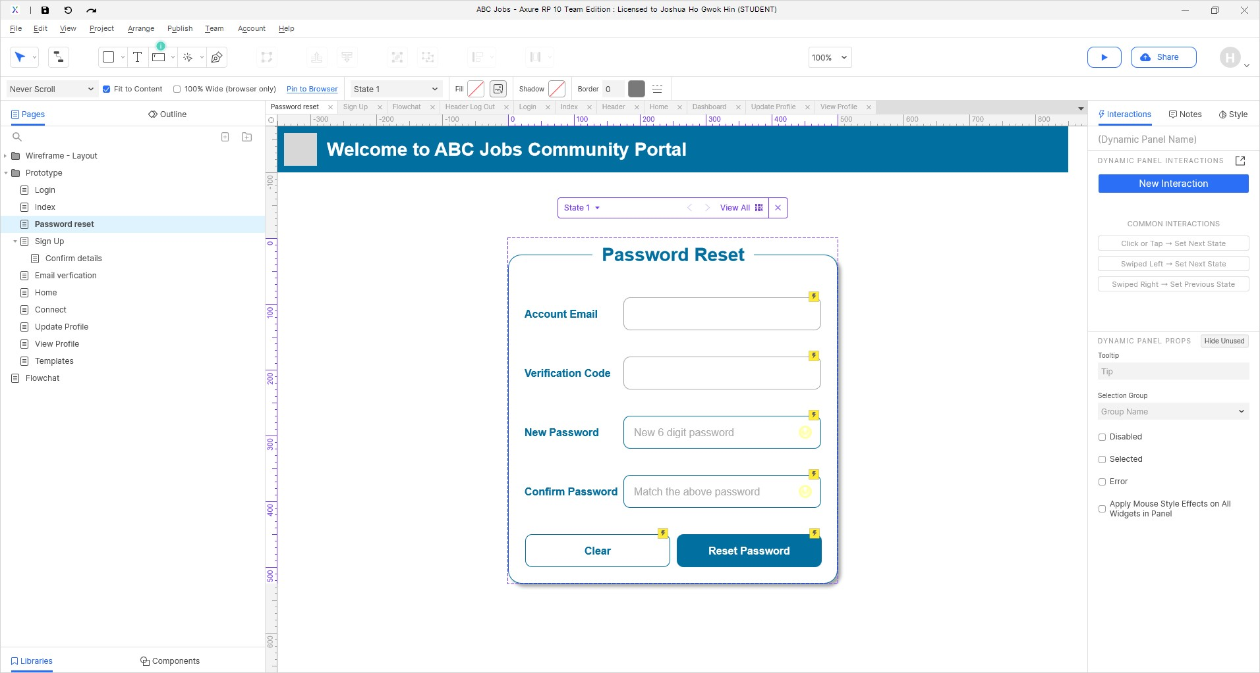

Excel for recording success and gather user feedback

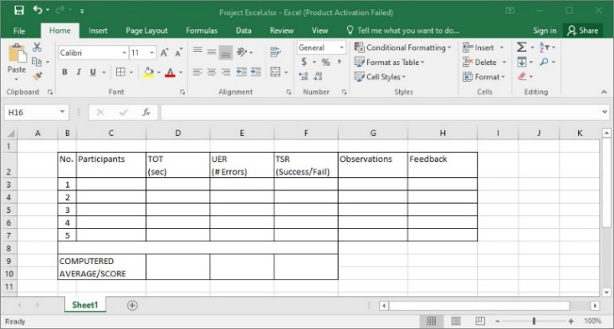

Record success and feedback through keen observation of users performing tasks.

1. Business Process & Solution Architecture
2. Business Process

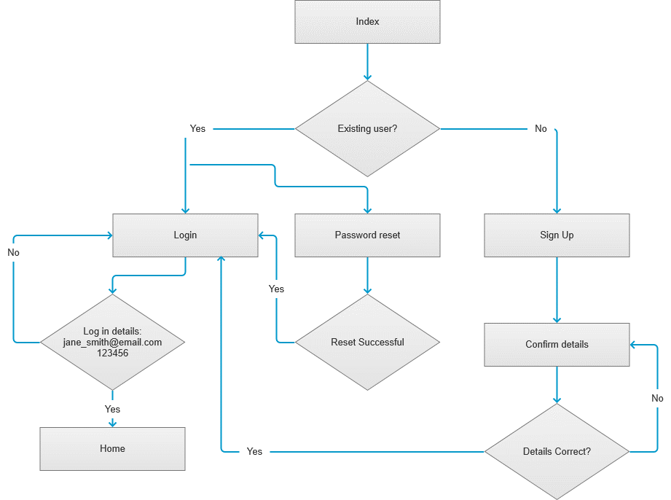

1. Solution Architect

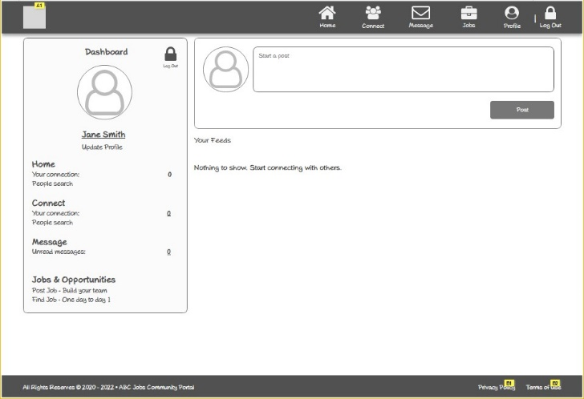 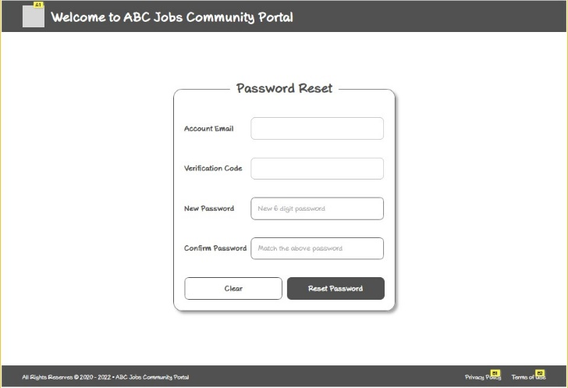

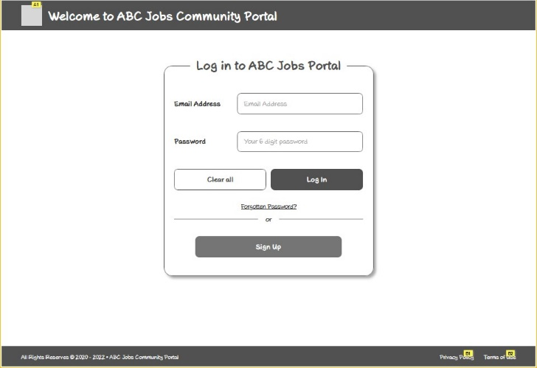 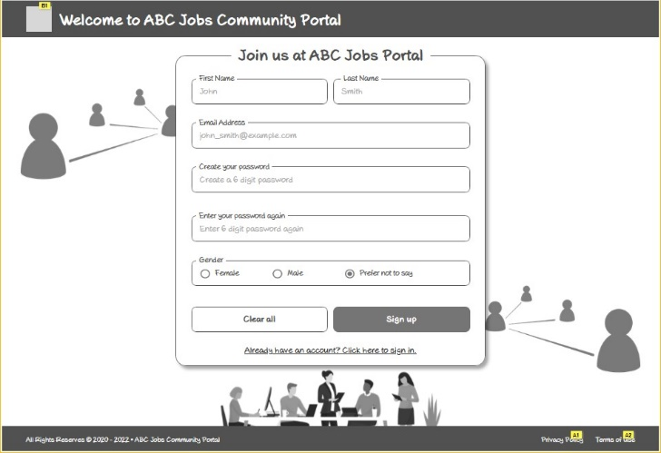

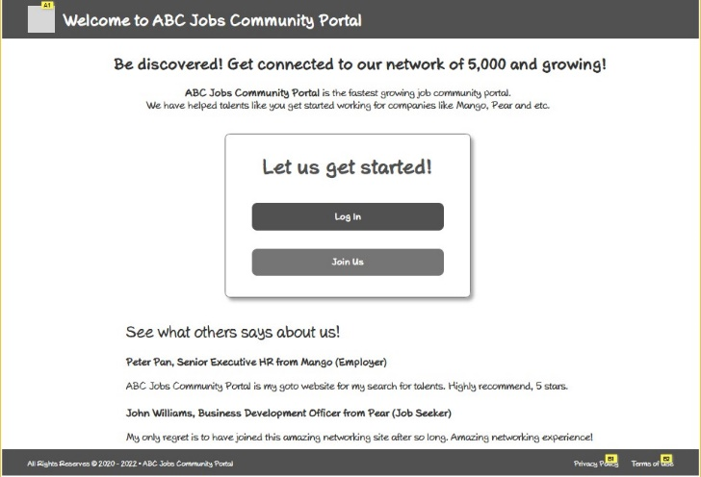 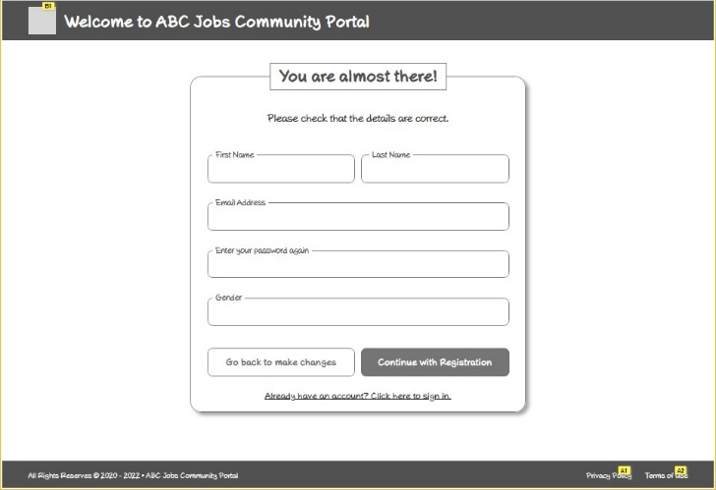

1. Task 1 (A1, K1)
2. **Briefly explain techniques and methods for gathering and analyzing user feedback.**

|  |  |  |
| --- | --- | --- |
| **No** | **Techniques and Methods** | **Brief description** |
| 1 | Interviewing | Communicate with users, get to know their pain points in using a product. |
| 2 | Observation (Site Visiting) | Site visiting is very suitable for observing and collecting data based on real situation of users performing tasks. |
| 3 | Conduct a study | Create an interview guide for the target user base that closely resembles Personas. Collect and record users as they think out loud. Write a report with findings. May include Success Rate KPI |

1. **Find at least 2 websites which are similar to community portal and visit and use them and record your experiences.**

|  |  |  |
| --- | --- | --- |
| **No** | **Website** | **User experience** |
| 1 | LinkedIn | I find the navigation is really simple with icons and labeling. Most of the time I am just browsing the around and read whatever that comes up. There is a mixture of content including those that I’m not really interested in at the moment. I would login to LinkedIn like three to four times per week. |
| 2 | Facebook | Facebook is my go to community portal for interesting feeds. Yes, interesting feeds that have mostly got nothing to do with my life. It has got pretty updated articles from news portal pages (if you follow them). One click will get me to the feed source. |

1. Task 2 (A2, K2) (Study the user experience & document them in Project Report)
2. **Discuss, study and analyses the user experience based on the observations done in Task 1.**

|  |  |  |
| --- | --- | --- |
| No | Website | Discussion and analysis |
| 1 | LinkedIn | Use of **icons** helps **users interacts visually**, **matching the real world experience**. |
| 2 | Facebook | Natural to use and satisfies user. User can **perform tasks intuitively.** |

1. **Study the experience for 2 to 3 scenarios**

|  |  |  |
| --- | --- | --- |
| **Website** | **Scenarios** | **User Experience** |
| LinkedIn | Log in | Log in as expected, no help needed. |
| View profile of a friend | Planned profile listed at the top of result. |
| Update Profile | Profile updated as expected. |
| Facebook | Log in | Log in as expected, no help needed. |
| View profile of a friend | Planned profile listed at the top of result. |
| Update Profile | Profile updated as expected. |

1. Task 3 (A3)

**Identify the performance levels and gaps between user experience in the study & desired user experience.**

Settings:  
 Task 1. Browser to be in incognito mode  
 Task 2. Must be account of same person on both platform  
 Task 3. Location to be set to China before start. To update country from China to Singapore.

|  |  |  |  |  |  |  |  |
| --- | --- | --- | --- | --- | --- | --- | --- |
| Platform | Scenario | Desired | | | Actual | | |
| TOT | TSR | UER | TOT | TSR | UER |
| LinkedIn | 1. Log In | 10 | 100% | 0% | 10 | 100% | 0% |
| 2. View Profile of a friend | 10 | 100% | 0% | 7 | 100% | 0% |
| 3. Password Reset | 15 | 100% | 0% | 21 | 100% | 0% |
| Facebook | 1. Log In | 10 | 100% | 0% | 10 | 100% | 0% |
| 2. View Profile of a friend | 10 | 100% | 0% | 8 | 100% | 0% |
| 3. Password Reset | 15 | 100% | 0% | 20 | 100% | 0% |

1. Task 4 (A4)

Develop & document 5 metrics to measure the user experience

Time-on-task (TOT): Measured in seconds.  
User Error Rate (UER): In percentage. (No of Error/ Total Participants X 100%)  
Task Success Rate (TSR): In percentage. (No. of successful/ Total of Participants X 100%)  
Net Promoter Score (NPS): A scale of 0 to 10. 0-6 Detractors, 7-8 Passives and 9-10 as Promoters.  
Customer Satisfaction (CSAT): 1-2 Very Bad, 3-4 Poor, 5-6 Average, 7-8 Good, 9-10 Excellent

|  |  |  |  |  |  |  |
| --- | --- | --- | --- | --- | --- | --- |
| No. | Participants | TOT (sec) | UER  (# Errors) | TSR (Success/Fail) | Observations | Feedback |
| 1 |  |  |  |  |  |  |
| 2 |  |  |  |  |  |  |
| 3 |  |  |  |  |  |  |
| 4 |  |  |  |  |  |  |
| 5 |  |  |  |  |  |  |
|  | | | | |  |  |
| COMPUTERED AVERAGE/SCORE | |  |  |  |  |  |

|  |  |  |  |  |
| --- | --- | --- | --- | --- |
| No. | Participants | NPS Ratings (0-10) | CSAT Ratings (1-10) | TSR (Success/Fail) |
| 1 |  |  |  |  |
| 2 |  |  |  |  |
| 3 |  |  |  |  |
| 4 |  |  |  |  |
| 5 |  |  |  |  |
|  | | | | |
| COMPUTERED AVERAGE/SCORE | |  |  |  |

1. Task 5 (K3, K4) phase 2
2. **Create the steps in User Interaction process for various scenario.**

Scenario 1: Login

1. User visit landing page and click on Log In button
2. User enter email address and password to click the submit button

Scenario 2: Registration

1. User visits landing page and click on Join Us button.
2. User enters required First Name, Email Address, Gender, Password and clicks Sign Up button
3. User redirected to confirm details page and check for errors, click Continue with Registration button
4. Pop up window for Email verification code, check and click Confirm my registration button
5. Redirected to login page

Scenario 3: Password Reset for Forgotten Password

1. User visit landing page and click on Log In button
2. User click on Forgotten Password? Link
3. Pop up request for Email address for password reset link and verification code to be sent.
4. Redirected to Password Reset page to key in new password with Password matching validation.
5. Pop up to inform Password Reset Successful. Click Proceed to log in page
6. Redirected back to log in page.
7. **Create a flow chart for user interaction.**

A. Log in B. Password Reset C. Registration

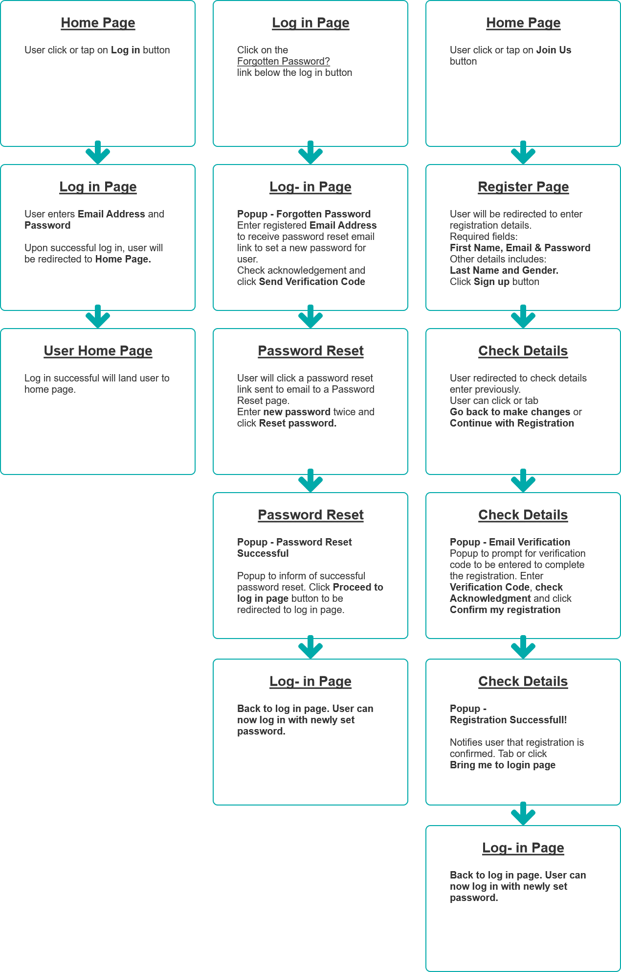

1. Task 6 (A5)

**In the Websites studies get the general user response from one other user.**

|  |  |  |
| --- | --- | --- |
| **No** | **Website** | **User experience** |
| 1 | LinkedIn | I got pretty confused if this is a friend making site or a job portal. I somehow felt compelled to have to add my bosses to my network. |
| 2 | Facebook | I have a lot of friends and Facebook has some options to help me follow closely to people whom I really care about. It helps organize the feeds based on the profile that I’m more concerned about. |

1. Task 7 (A6) phase 2
2. **Create a Prototype for the proposed system, with at least 5 scenarios.**

**Scenario 1: Log in**

|  |  |  |
| --- | --- | --- |
| No | Screen-shots of pages | Widget/Interaction Table |
| 01 |  | |  |  |  | | --- | --- | --- | | Note number | Name | Note | | 1 | Log In Button | Redirect to Log In Page | | 2 | Join Us Button | Redirect to Register an account Page | | 11 | Popup Forgotten Password | Popup to request for Password Reset | |
| 02 |  | |  |  |  | | --- | --- | --- | | Note number | Name | Note | | 1 | Email (Required Input) | Email Address Required Input Field | | 2 | Password (Required) | Email Address Required Input Field | | 3 | Green Tick | Show if field is not equal " " | | 4 | Green Tick | Show if field is not equal " " | | 5 | Red ! | Show if field is equal " " | | 6 | Red ! | Show if field is equal " " | | 7 | Clear all button | Clear Email & Password | | 8 | Log In Button | Form validation. If true, go to home page of user. | | 9 | Forgotten Password Link | Activates Popup for Password Reset | | 10 | Sign Up Button | Redirect to Sign Up Page | |
| 03 |  | |  |  |  | | --- | --- | --- | | Note number | Name | Note | | 1 | navbar-brand | 1:1 Image | | 2 | Navigation Bar | Navbar Header | | 3 | Popup | Popup - Confirm Sign out | | 8 | navbar-brand | Links to Home Page | |

**Scenario 2: Registration**

|  |  |  |
| --- | --- | --- |
| No | Screen-shots of pages | Widget/Interaction Table |
| 01 |  | |  |  |  | | --- | --- | --- | | Note number | Name | Note | | 1 | Log In Button | Redirect to Log In Page | | 2 | Join Us Button | Redirect to Register an account Page | | 11 | Popup Forgotten Password | Popup to request for Password Reset | |
| 02 |  | |  |  |  | | --- | --- | --- | | Note number | Name | Note | | 1 | First Name (Required) | First Name Required Field | | 2 | Last Name | Last Name | | 3 | Email Address (Required) | Email Address with Validation | | 4 | New Password Input (Required) | New Password with Validation | | 5 | Password Confirm (Required) | Enter Password Confirmation with Validation | |
| 03 |  | |  |  |  | | --- | --- | --- | | Note number | Name | Note | | 1 | First Name | Auto Populate First Name | | 2 | Last Name | Auto Populate Last Name | | 3 | Email Address | Auto Populate Email Address | | 4 | New Password | Auto Populated New Password | | 5 | Gender | Auto Populated Gender Field | | 6 | Go Back Button | Links to Sign Up page to make changes | | 7 | Continue Button | Activate Popup Registratioin Confirmation | |

**Scenario 2: Registration (Continue)**

|  |  |  |
| --- | --- | --- |
| No | Screen-shots of pages | Widget/Interaction Table |
| 04 |  | |  |  |  | | --- | --- | --- | | Note number | Name | Note | | 11 | Enter verification Code | Enter verification code sent to email | | 12 | Cancel Button | Close popup and return to previous state. | | 13 | Confirm Button | Validates verification code and show popup Registration Successful | |
| 05 |  | |  |  |  | | --- | --- | --- | | Note number | Name | Note | | 9 | Close window button | Close window redirect to log in page | |
| 06 |  | |  |  |  | | --- | --- | --- | | Note number | Name | Note | | 1 | Email (Required Input) | Email Addresss Required Input Field | | 2 | Password (Required) | Email Addresss Required Input Field | | 3 | Green Tick | Show if field is not equal " " | | 4 | Green Tick | Show if field is not equal " " | | 5 | Red ! | Show if field is equal " " | | 6 | Red ! | Show if field is equal " " | | 7 | Clear all button | Clear Email & Password | | 8 | Log In Button | Form validation. If true, go to home page of user. | | 9 | Forgotten Password Link | Activates Popup for Password Reset | | 10 | Sign Up Button | Redirect to Sign Up Page | |

**Scenario 3: Password Reset**

|  |  |  |
| --- | --- | --- |
| No | Screen-shots of pages | Widget/Interaction Table |
| 01 |  | |  |  |  | | --- | --- | --- | | Note number | Name | Note | | 1 | Email (Required Input) | Email Addresss Required Input Field | | 2 | Password (Required) | Email Addresss Required Input Field | | 3 | Green Tick | Show if field is not equal " " | | 4 | Green Tick | Show if field is not equal " " | | 5 | Red ! | Show if field is equal " " | | 6 | Red ! | Show if field is equal " " | | 7 | Clear all button | Clear Email & Password | | 8 | Log In Button | Form validation. If true, go to home page of user. | | 9 | Forgotten Password Link | Activates Popup for Password Reset | | 10 | Sign Up Button | Redirect to Sign Up Page | |
| 02 |  | |  |  |  | | --- | --- | --- | | Note number | Name | Note | | 12 | Email Field | Enter Email Address for the account to have password reset. | | 13 | Acknowledge Checkbox | Acknowledgement that this will send an alert to the account for password reset. | | 14 | Cancel Button | Cancel popup and return to previous state. | | 15 | Close Icon | Cancel popup and return to previous state. | | 16 | Send Verification Email | Click to send verification email to user. | |
| 03 |  | |  |  |  | | --- | --- | --- | | Note number | Name | Note | | 1 | Links to Reset Password | Links to Password Reset Page | |
| 04 |  | |  |  |  | | --- | --- | --- | | Note number | Name | Note | | 1 | Account Email | Auto Populate onload | | 2 | Verification | Auto Populate onload | | 3 | New Password | With Validation | | 4 | Red ! | Show if input is equal to " " | | 5 | Green Tick | Show if input is not equal to " " | | 6 | Confirm Password | With Validatoin | | 7 | Red ! | Show if input is equal to " " | | 8 | Green Tick | Show if input is not equal to " " | | 9 | Clear Button | Clear New Password and Confirm Password Input Fields | | 10 | Reset Password | Save new password upon successful validation | |
| 05 |  | |  |  |  | | --- | --- | --- | | Note number | Name | Note | | 12 | Proceed to log in page | Redirect to log in page | |
| 06 |  | |  |  |  | | --- | --- | --- | | Note number | Name | Note | | 1 | Email (Required Input) | Email Addresss Required Input Field | | 2 | Password (Required) | Email Addresss Required Input Field | | 3 | Green Tick | Show if field is not equal " " | | 4 | Green Tick | Show if field is not equal " " | | 5 | Red ! | Show if field is equal " " | | 6 | Red ! | Show if field is equal " " | | 7 | Clear all button | Clear Email & Password | | 8 | Log In Button | Form validation. If true, go to home page of user. | | 9 | Forgotten Password Link | Activates Popup for Password Reset | | 10 | Sign Up Button | Redirect to Sign Up Page | |

**Scenario 3: Password Reset**

**Scenario 4: Search other users**

|  |  |  |
| --- | --- | --- |
| No | Screen-shots of pages | Widget/Interaction Table |
| 01 |  | |  |  |  | | --- | --- | --- | | Note number | Name | Note | | 1 | navbar-brand | 1:1 Image | | 2 | Navigation Bar | Navbar Header | | 3 | Popup | Popup - Confirm Sign out | | 8 | navbar-brand | Links to Home Page | |
| 02 |  | |  |  |  | | --- | --- | --- | | Note number | Name | Note | | 1 | Your Network Tab | Shows user's connection | | 2 | Search Users Tab | Switch to search function to search for user | | 3 | Search user Button | Switch to search function to search for user | |
| 03 |  | |  |  |  | | --- | --- | --- | | Note number | Name | Note | | 4 | Search Results | Display suggested search results | | 5 | Search Input | Search for user(s) | | 6 | Search Button | Display search results onclick | |
| 04 |  | |  |  |  | | --- | --- | --- | | Note number | Name | Note | | 7 | Search Input | Search for user(s) | | 8 | Search Button | Display search results onclick | |

**Scenario 5: Update Profile**

|  |  |  |
| --- | --- | --- |
| No | Screen-shots of pages | Widget/Interaction Table |
| 01 |  | |  |  |  | | --- | --- | --- | | Note number | Name | Note | | 1 | navbar-brand | 1:1 Image | | 2 | Navigation Bar | Navbar Header | | 3 | Popup | Popup - Confirm Sign out | | 8 | navbar-brand | Links to Home Page | |
|  |  | |  |  |  | | --- | --- | --- | | Note number | Name | Note | | 1 | Change profile details Button | Redirect to Update profile page | |
| 01 |  | |  |  |  | | --- | --- | --- | | Note number | Name | Note | | 1 | First Name Input | Auto populate First Name | | 2 | Last Name Input | Auto populate Last Name | | 3 | Email Input | Auto populate Email Address | | 4 | Phone Number Input | Auto populate Phone Number | | 5 | Month Input | Auto populate Month | | 6 | Day Input | Auto populate Day | | 7 | Year Input | Auto populate Year | | 8 | Street Address Input | Auto populate Street Address | | 9 | Save Button | Save variables of fields | | 10 | Back to home button | Redirect to home page | |
| 02 |  |  |
| 03 |  | |  |  |  | | --- | --- | --- | | Note number | Name | Note | | 1 | First Name Input | First Name Updated | | 2 | Last Name Input | Last Name Updated | | 3 | Email Input | Email Updated Address | | 4 | Phone Number Input | Phone Number Updated | | 5 | Month Input | Month Updated | | 6 | Day Input | Day Updated | | 7 | Year Input | Year Updated | | 8 | Street Address Input | Street Address Updated | | 9 | Save Button | Save variables of fields | | 10 | Back to home button | Redirect to home page | |

1. **Get the user response and classify them to various types.**

|  |  |  |  |  |
| --- | --- | --- | --- | --- |
| User Name | Task | Scenario Description | Feedback and response | Possible UI Principle Violation |
| Christopher | Scenario 1: Log in | After keying in email address and password, user is unsure to click log in or sign up. User hesitated on choosing sign up or log in button. | Can I sign up after entering email and password? | Log in button fail to provide informative feedback. There is no visual clue between log in and sign up button. |
| Scenario 2: Sign up | During sign up session, user missed the First Name field and filled up the rest of the details and clicked sign up. Validation failed and showed a red exclamation mark. | Do I need to click to know that a field is required? | Input fields lacking visual clue as required fields. The design that relies on informative feedback from validation is not ideal. |

1. Task 8 (A7) (Do after Task 9 Gather feedback for the prototypes and document, make suggestions for improvement and document them in Project Presentation)
2. **Demonstrate and let the users give feedback on prototype and document them**

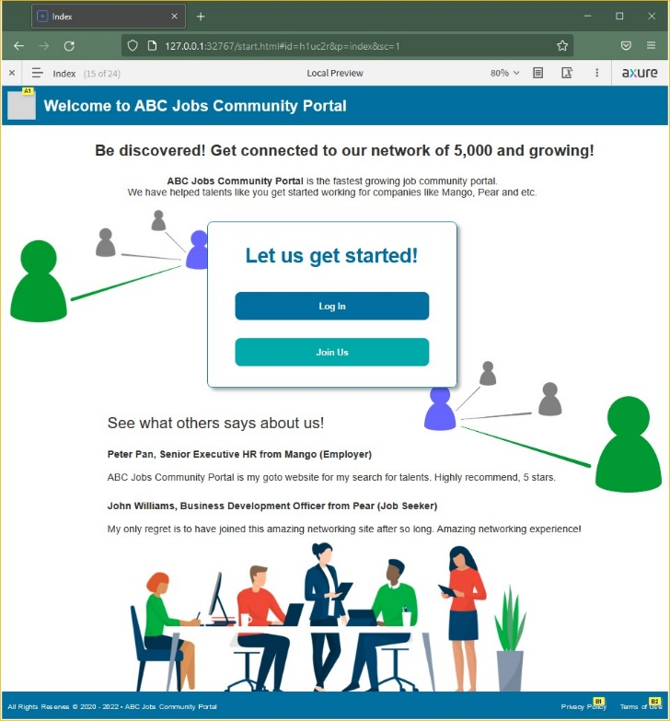 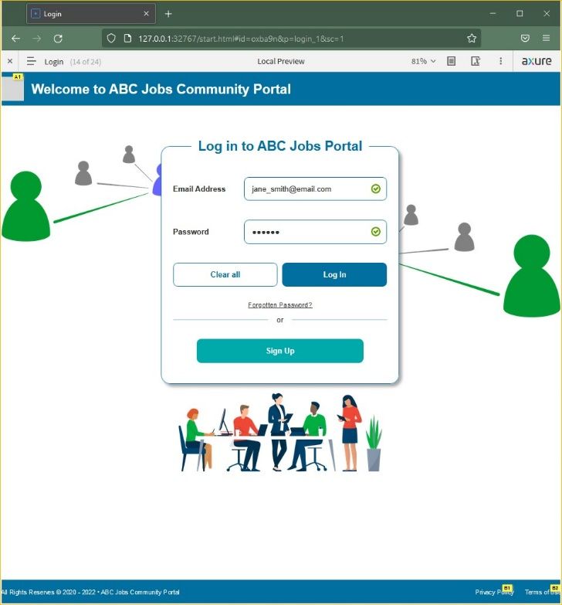

**Scenario 1: Log in**

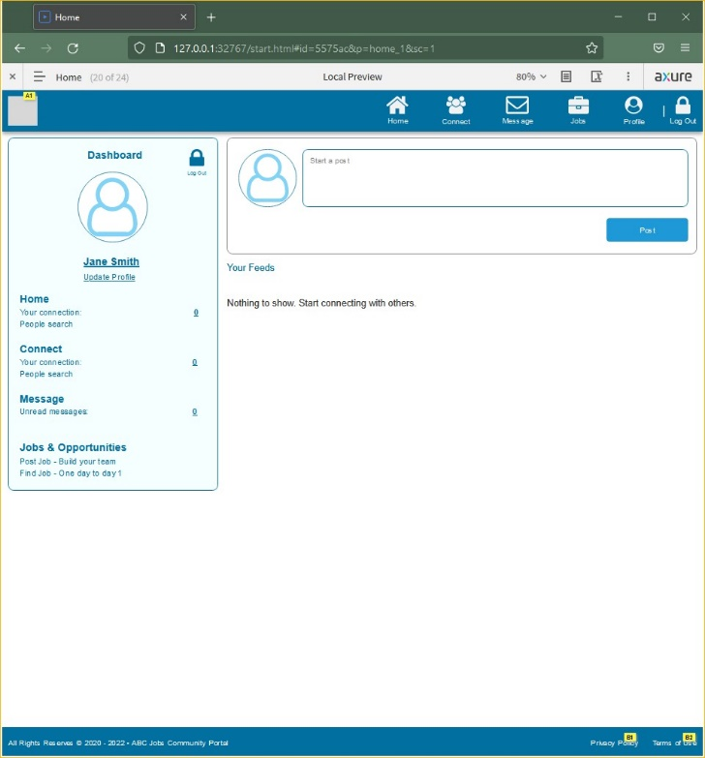

 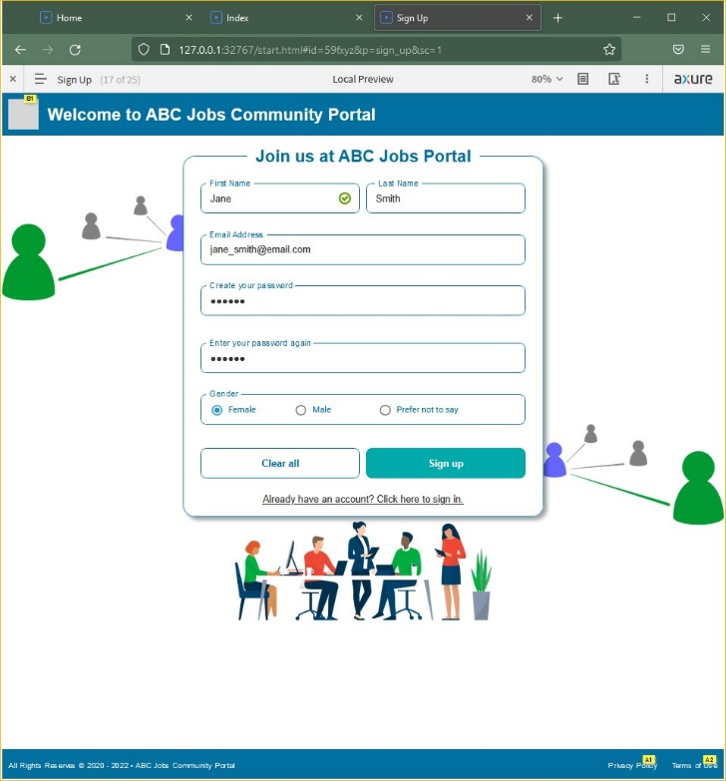 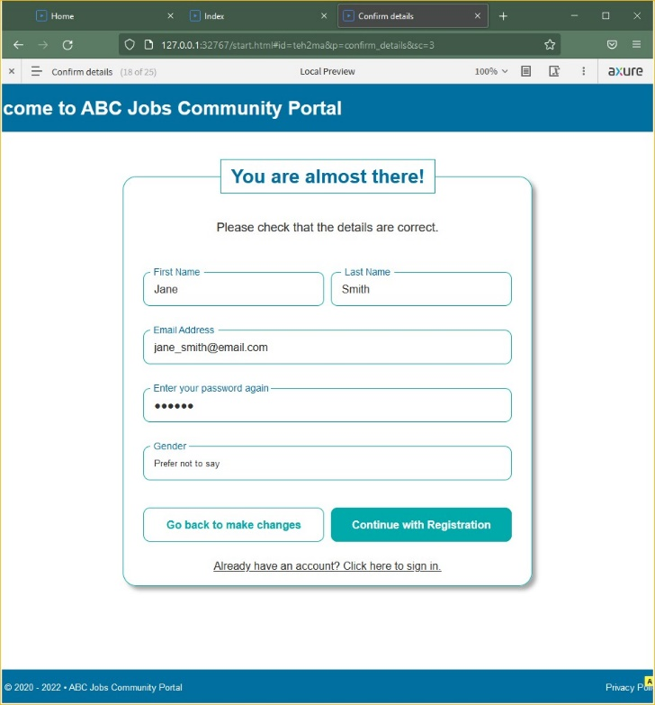 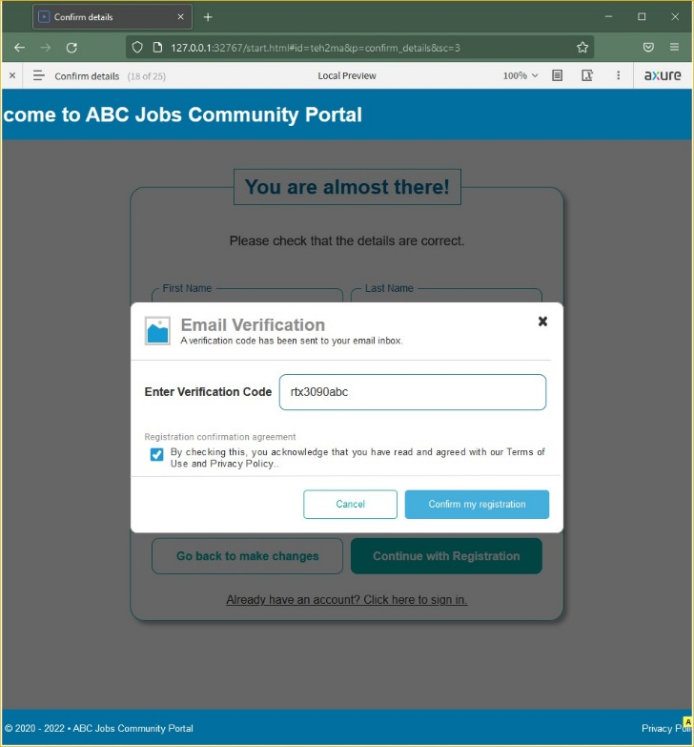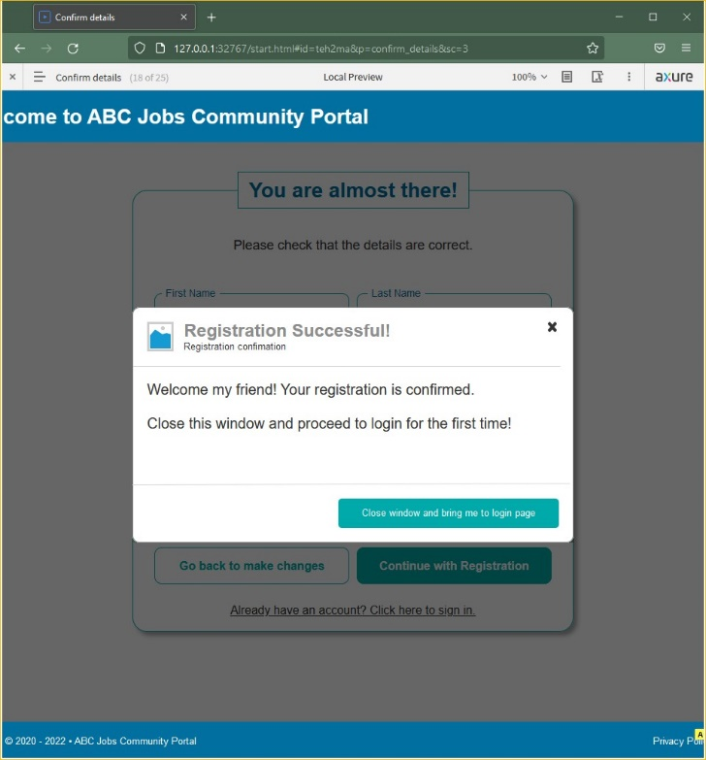 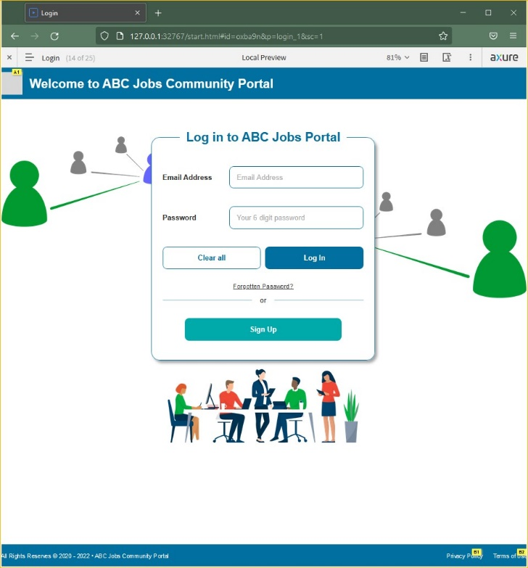

**Scenario 2: Registration**

 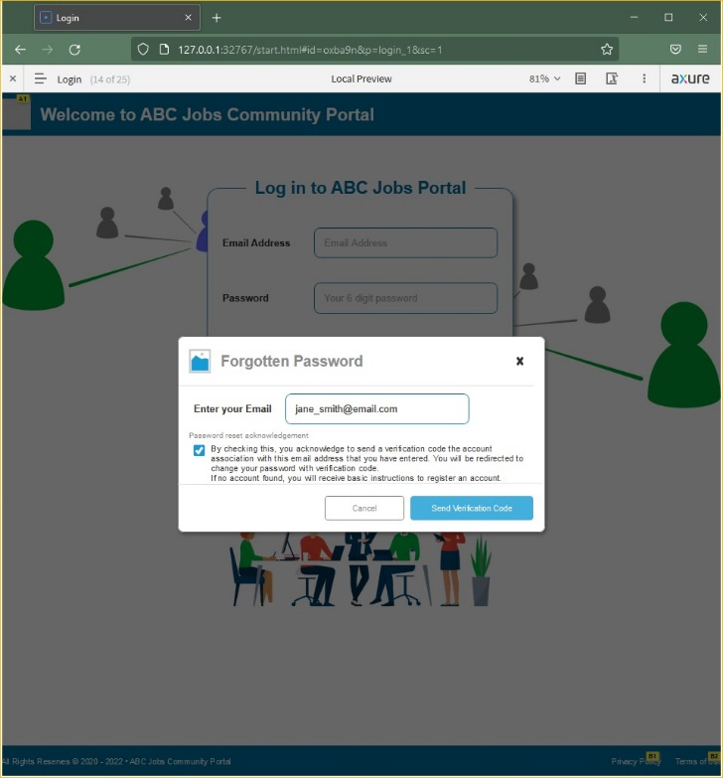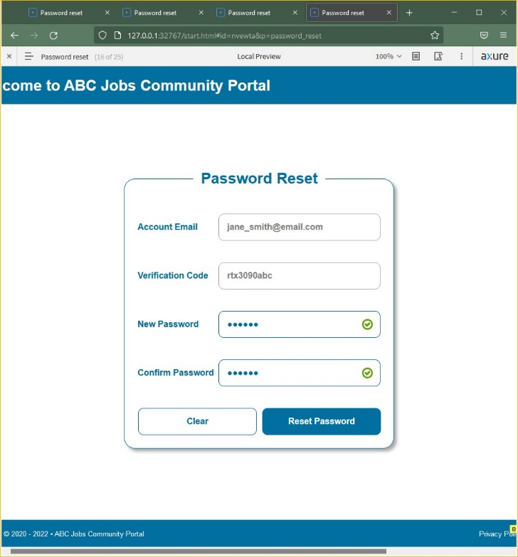 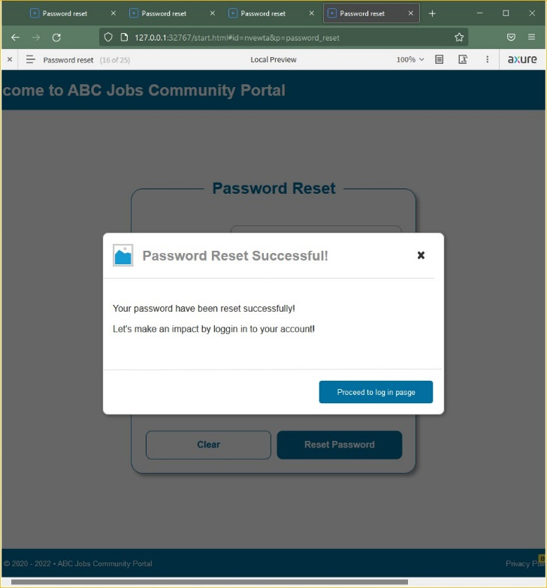

**Scenario 3: Password Reset**

|  |  |  |
| --- | --- | --- |
| **User Feedback Form**  **User: Nilofar** | | |
| **No.** | 1. **Document user’s feedback and response** | 1. **Make suggestions to improve the user experience and implement them in prototype.** |
| 01 | Is the logo really grey in color?  I don’t like the icon 😕 | **Update design** to match theme. |
| 02 | When I am resetting password, I got the verification code pre-filled in the form after I key in the email. Do I need to type this somewhere? So anyone can put my email and change my password? | After resetting password, the **close button will no longer redirect to verification page.** For security reason, **email verification page will only be able to access via email verification link.** |
| 03 | I can see the password I type in reset password… I don’t think this is safe… | Password input field to change to  **<input type="password">** |
| 04 | My profile is not updating after I change the name (scrolling is also a problem here) | Make adjustments to styling to troubleshoot for rendering error. |
| 05 | Why are there no software programmers? | Double check and review Personas and test data to fulfill client’s requirement for next round of testing, if any. |

1. Task 9 (K5, K6, A8)
2. **Create 5 Usability tests and execute the usability tests with a user**

**Usability Tests Plan**

|  |  |  |  |  |
| --- | --- | --- | --- | --- |
| **No** | **Scenarios** | **No of user(s)** | **No of test conducted** | **Facilitator** |
| 1 | Log in | 5 | 5 | Joshua |
| 2 | Password Reset | 5 | 5 | Joshua |
| 3 | Register for an account | 5 | 5 | Joshua |
| 4 | Search other users | 5 | 5 | Joshua |
| 5 | Update Profile | 5 | 5 | Joshua |

1. **Gather feedback and measure its technical viability and effectiveness**

|  |  |  |  |  |
| --- | --- | --- | --- | --- |
| **No.** | **Participants** | **NPS Ratings (0-10)** | **CSAT Ratings (1-10)** | **TSR (Success/Fail)** |
| 1 | Danny | 8 | 9 | 100 |
| 2 | John | 7 | 7 | 100 |
| 3 | Eugene | 9 | 8 | 100 |
| 4 | Daniel | 7 | 8 | 100 |
| 5 | Shawn | 10 | 10 | 100 |
|  | | | | |
| **COMPUTERED AVERAGE/SCORE** | | 8.2 | 8.4 | 100% |

**Feedback of modified Prototype**

|  |  |  |
| --- | --- | --- |
| **No.** | **Participants** | **Feedback** |
| 1 | Danny | Looks boring with little or no variations in color palette |
| 2 | John | I cannot change my profile picture? |
| 3 | Eugene | I am not sure if the data are actually updated after changing some details |
| 4 | Daniel | Everything seems fine but would be nice to make it look more interesting. |
| 5 | Shawn | Pretty cool, let me know when it is ready I’d be coming onboard. |

1. Appendix A: Detail UX Testing Report

FUNCTION 1: Log In

|  |  |  |  |  |  |  |
| --- | --- | --- | --- | --- | --- | --- |
| No. | Participants | TOT (sec) | UER  (# Errors) | TSR (Success/Fail) | Observations | Feedback |
| 1 | Danny | 10 | 0 | 100 |  |  |
| 2 | John | 9 | 0 | 100 |  |  |
| 3 | Eugene | 8 | 0 | 100 |  |  |
| 4 | Daniel | 11 | 0 | 100 |  |  |
| 5 | Shawn | 7 | 0 | 100 |  |  |
|  | | | | |  |  |
| COMPUTERED AVERAGE/SCORE | | 9 Sec | 0% | 100% |  |  |
|  |  |

FUNCTION 2: Password Reset

|  |  |  |  |  |  |  |
| --- | --- | --- | --- | --- | --- | --- |
| No. | Participants | TOT  (sec) | UER  (# Errors) | TSR (Success/Fail) | Observations | Feedback |
| 1 | Danny | 12 | 0 | 100 |  |  |
| 2 | John | 13 | 0 | 100 |  |  |
| 3 | Eugene | 11 | 0 | 100 |  |  |
| 4 | Daniel | 10 | 0 | 100 |  |  |
| 5 | Shawn | 13 | 0 | 100 |  |  |
|  | | | | |  |  |
| COMPUTERED AVERAGE/SCORE | | 11.8 Sec | 0% | 100% |  |  |

FUNCTION 3: Register

|  |  |  |  |  |  |  |
| --- | --- | --- | --- | --- | --- | --- |
| No. | Participants | TOT  (sec) | UER  (# Errors) | TSR (Success/Fail) | Observations | Feedback |
| 1 | Danny | 35 | 0 | 100 |  |  |
| 2 | John | 30 | 0 | 100 |  |  |
| 3 | Eugene | 28 | 0 | 100 |  |  |
| 4 | Daniel | 35 | 0 | 100 |  |  |
| 5 | Shawn | 22 | 0 | 100 |  |  |
|  | | | | |  |  |
| COMPUTERED AVERAGE/SCORE | | 30 Sec | 0% | 100% |  |  |

FUNCTION 4: Search Other Users

|  |  |  |  |  |  |  |
| --- | --- | --- | --- | --- | --- | --- |
| No. | Participants | TOT  (sec) | UER  (# Errors) | TSR (Success/Fail) | Observations | Feedback |
| 1 | Danny | 25 | 0 | 100 |  |  |
| 2 | John | 30 | 0 | 100 |  |  |
| 3 | Eugene | 20 | 0 | 100 |  |  |
| 4 | Daniel | 35 | 0 | 100 |  |  |
| 5 | Shawn | 22 | 0 | 100 |  |  |
|  | | | | |  |  |
| COMPUTERED AVERAGE/SCORE | | 26.4 Sec | 0% | 100% |  |  |

FUNCTION 5: Update Profile

|  |  |  |  |  |  |  |
| --- | --- | --- | --- | --- | --- | --- |
| No. | Participants | TOT  (sec) | UER  (# Errors) | TSR (Success/Fail) | Observations | Feedback |
| 1 | Danny | 22 | 0 | 100 |  |  |
| 2 | John | 21 | 0 | 100 |  |  |
| 3 | Eugene | 18 | 0 | 100 |  |  |
| 4 | Daniel | 14 | 0 | 100 |  |  |
| 5 | Shawn | 12 | 0 | 100 |  |  |
|  | | | | |  |  |  |
| COMPUTERED AVERAGE/SCORE | | 17.4 Sec | 0% | 100% |  |  |

1. Appendix B: References